EXPERIMENT NO. 09
AIM: To study and design the 4-bit common bus system using tri state buffer.
TOOLS USED: Circuit verse simulator, gates, connecting leads, LED to observe output state
Theory: A tri-state buffer is a logic inverter or a non-inverting buffer with a tri-state output stage. A three-state bus buffer is an integrated circuit that connects multiple data sources to a single bus. The open drivers can be selected to be either a logical high, a logical low, or high impedance which allows other buffers to drive the bus.
Bus system with three-state buffers
The outputs of the four buffers are connected together to form a single bus line.The control inputs to the buffers determine which of the four normal inputs will communicate with the bus lines.No more than one buffer may be in the active state at any given time.The connected buffers must be controlled so that only one three-state buffer has access to the bus line while others are in high impedence.Decoder can be used to control the active input at any given time. When enable input of decoder is 0 all the outputs are zero and the lines are in high impedance. When enable is 1 than one of the four output of decoder is active depending upon binary values of the selection lines.
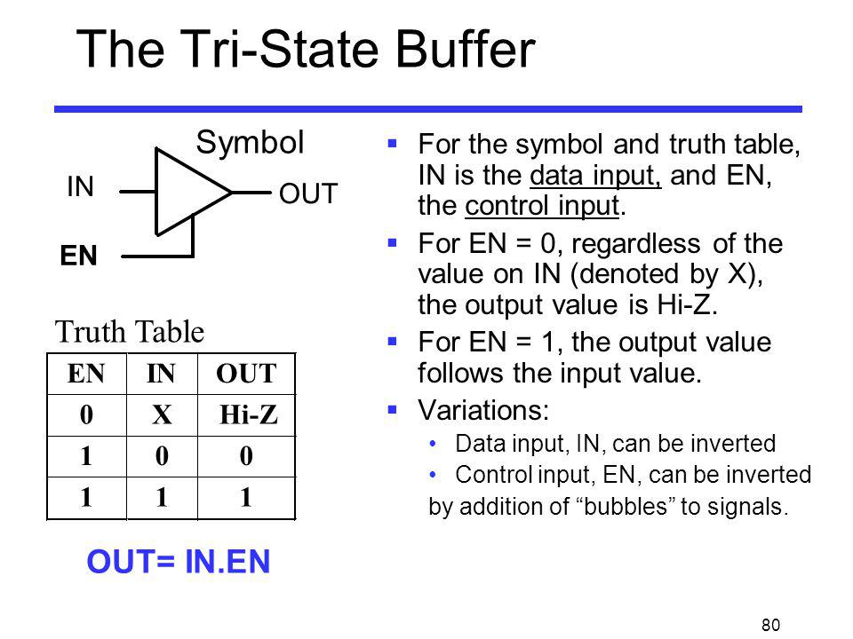
TRI-STATE BUFFER

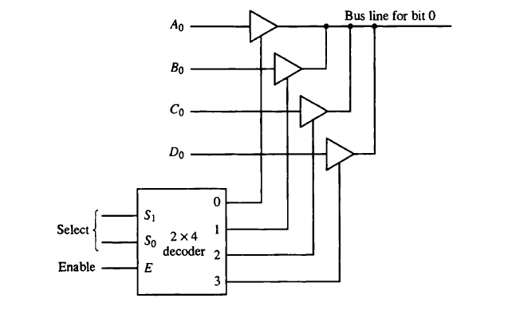
OBSERVATION:
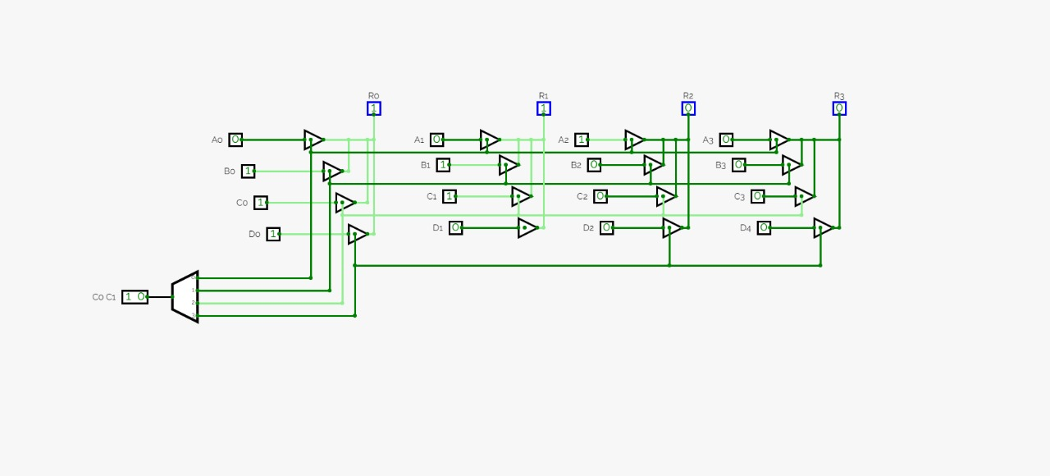
RESULT: 4-bit common bus system using tri state buffer has been designed and verified.
